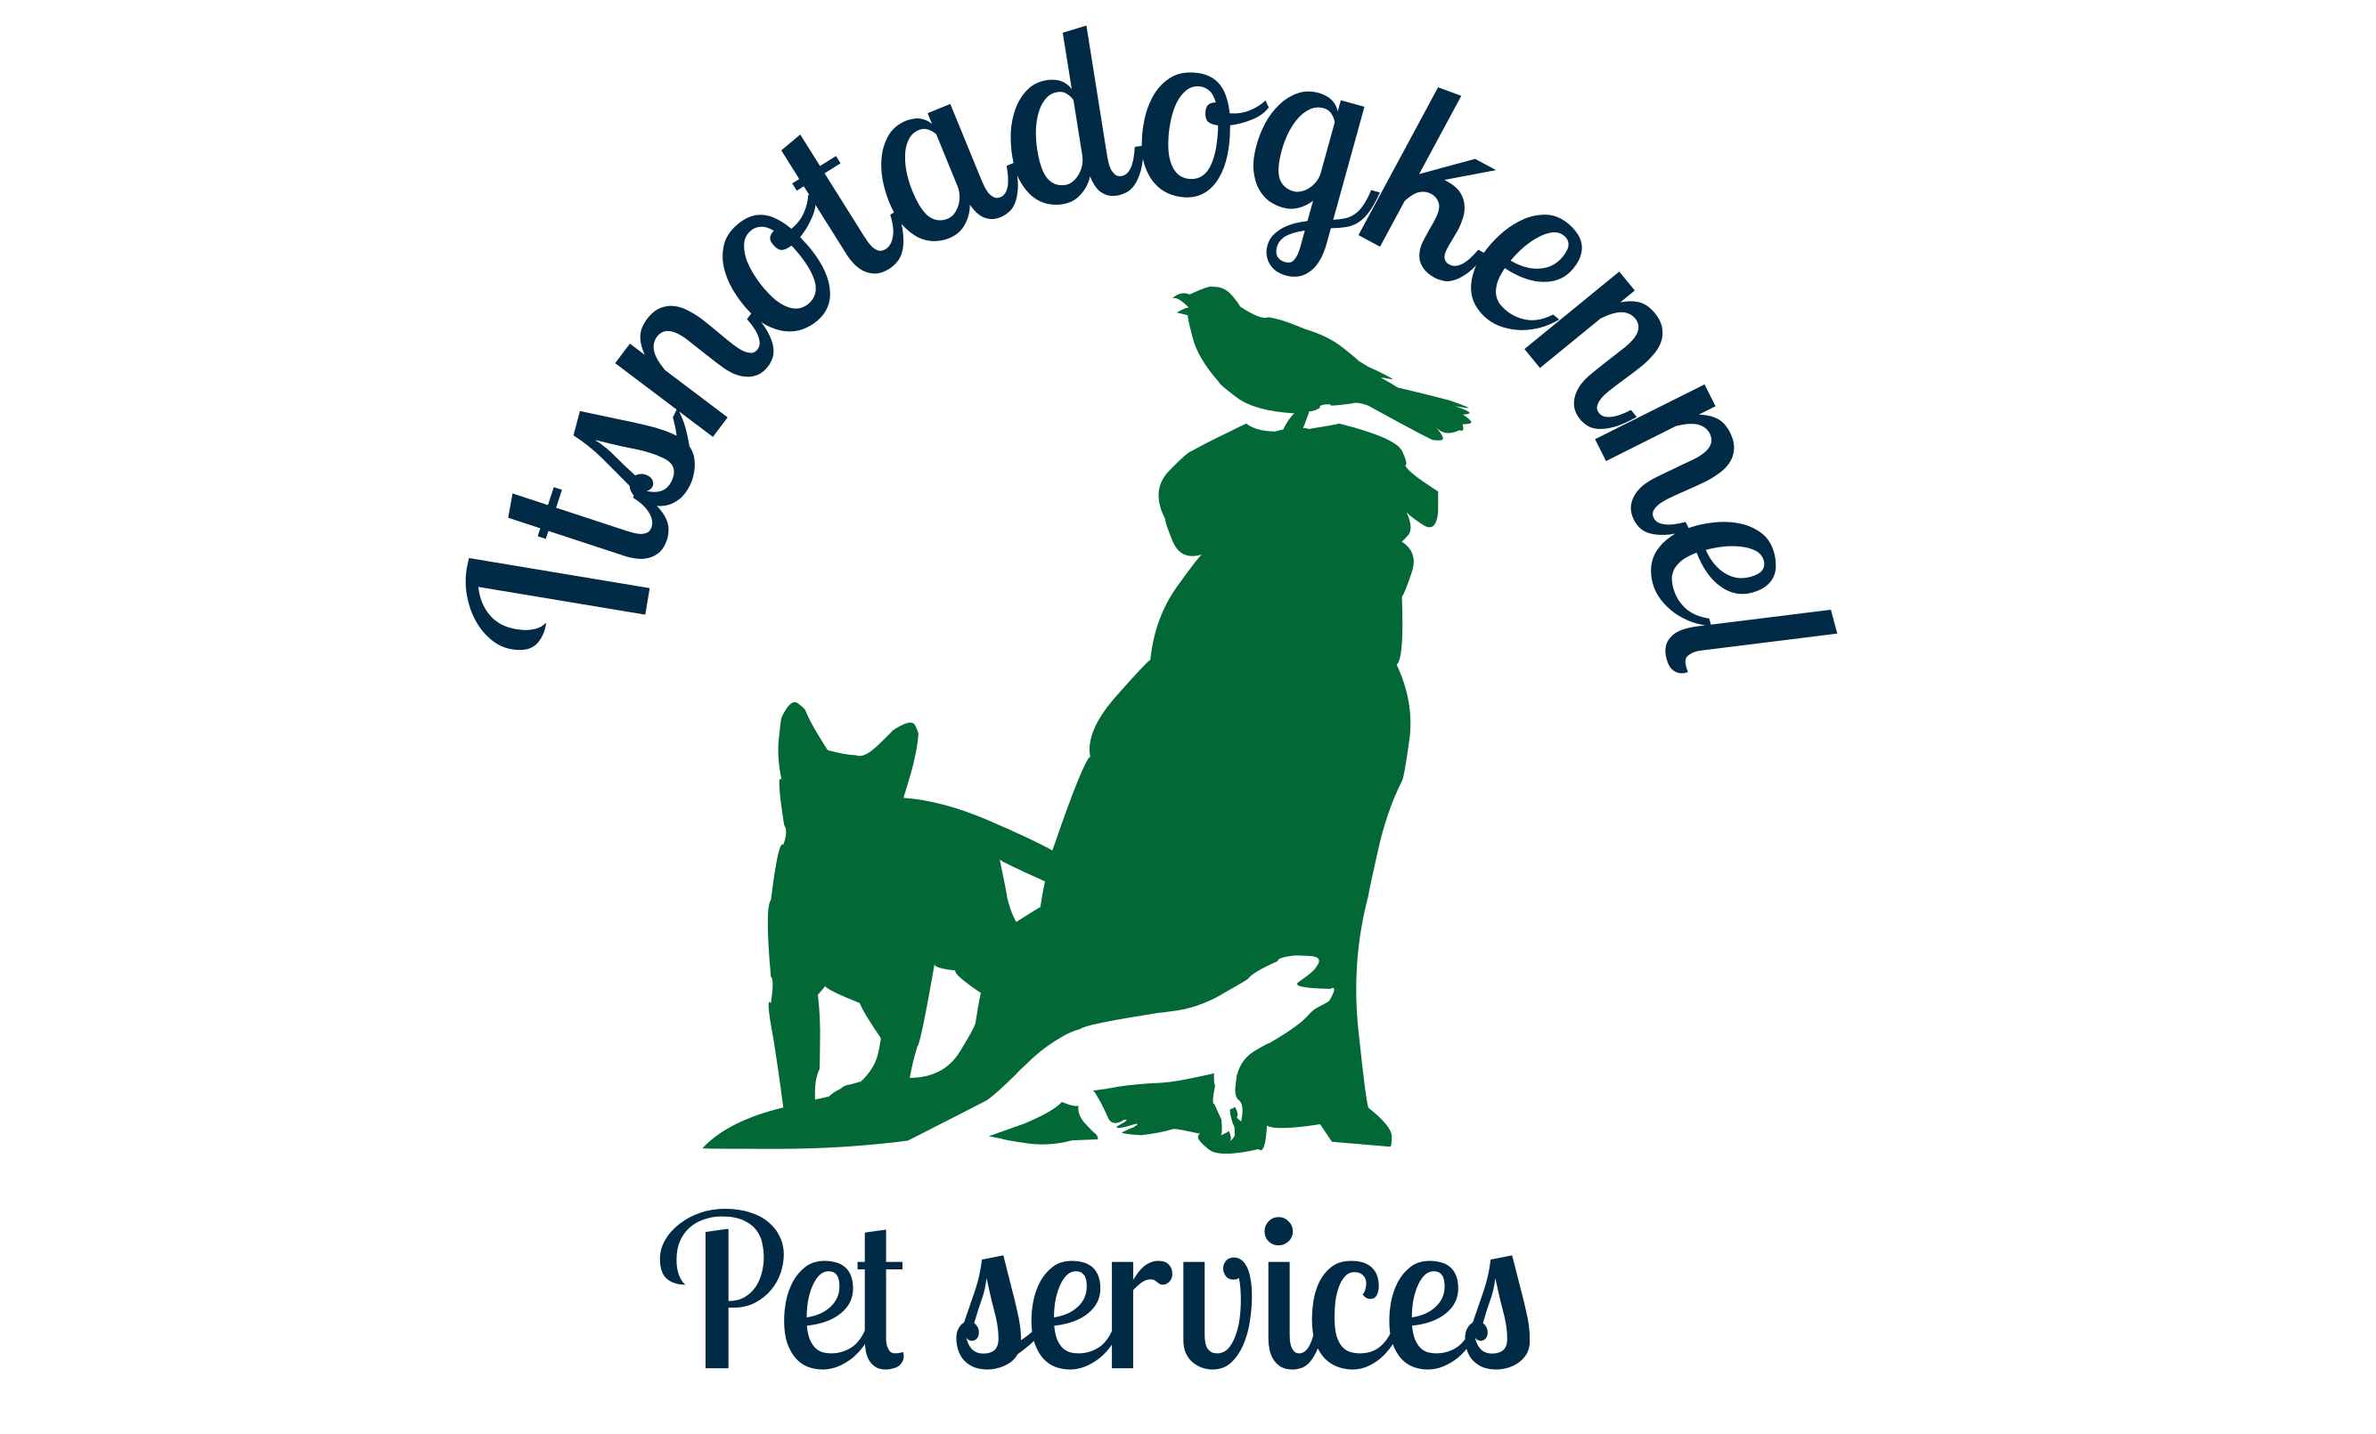

PET SITTING/DOG WALKING BOOKING FORM

Please complete the following form and email/post it back to us to book our services.
Information held is private and confidential

CONTACT DETAILS
Title: Mr/Mrs/Ms/Miss/Other (please specify)
First Name:
Surname:
Address:

Postcode:
Tel (Home):
Tel (Mobile)
Email:
EMERGENCY CONTACT

1ST Emergency contact name:
1st Emergency contact tel:
MEDICATION
Are your pets on any medication? YES/NO
Details:
PET DETAILS
Name of pet(s):
Species/Breed:
Colour:
Sex:
Neutured/spayed?:
Date of birth:
Pet insurance company:
VET DETAILS
Name of vet:
Vet telephone number:
Please confirm the below conditions:
During my absence, itsnotadogkennel.com’s pet sitter will be caring for my pet and I give permission to transport them to your surgery for treatment. I authorise you to treat my pet(s) and I will be responsible for the payment in all cases
YES/NO
DOG/CAT DETAILS
Does anything frighten your dog/cat?
Can your dog be let off the lead? If so, please sign the ‘Off the leash form’
Is your dog/cat good with other dogs/people and children?
Has your dog ever shown any signs of aggression?
Other pet(s) details:
SERVICE AND DATES REQUIRED:
Dog walking, Home-care (in a carers home) or Live-in Pet sitter (at your own home)?:

For dog walking
30 min or 1 hour visits? Time? :
For pet sitting/home-care
Your departure date and time:
Your return date and time:
Time of pet sitter’s arrival and departure (if different to the above):
Number of days service is required (Please note our charge is per calendar day not per 24 hour period) :
Services requested and duration eg. “x3 30 minute visits each day” or “12 days Home-care”

BOOKING CONFIRMATION:
I hereby confirm that I am the owner of the above pet(s) and that I authorise a itsnotadogkennel.com pet sitter to act as carer for my pet during my absence, for the dates/times specified above. I confirm that I allow for the pet sitter to take any action which he/she considers to be suitable in order to keep in good health the above named pet(s). I will however be responsible for any further costs incurred, either veterinary or other, as a result of sickness, accident or damage caused to or by the above named pet(s) .I also give my permission for the pet sitter to transport my pet in their vehicle in case of any emergency during my absence. I fully understand the terms and conditions listed below and agree to them.

PRINT NAME

SIGNATURE

DATE

Please post to: Itsnotadogkennel Pet Services, Woodlings Barn, Newnham Bridge, Tenbury Wells, Worcs, WR15 8JF
Or by email to itsnotadogkennelteam@gmail.com

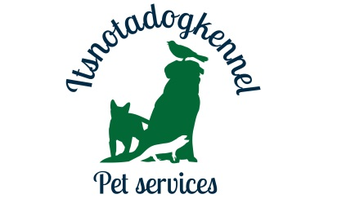
Terms and Conditions
- All clients will be deemed to have accepted itsnotadogkennel.com’s terms and conditions (as laid out below) on signature of the Booking Form. Itsnotadogkennel.com reserves the right to consider changes.
- itsnotadogkennel.com undertakes to treat all data about clients, sitters, prospective clients and prospective sitters as strictly confidential unless all parties agree otherwise.
- itsnotadogkennel.com will not confirm any booking until an initial consultation has taken place with the client and the booking form, including full details of the client’s requirements, has been signed by the client.
- The deposit payable to the company to confirm the booking and reserve the dates is non-refundable. This is because it covers our admin costs, insurance and turning down bookings to other clients for the dates the client has requested.
- The remaining fee for the pet sitting/dog walking service is to be settled before your departure.
- If the deposit payment is not settled within 7 days of the date of the invoice, then 3% of the total bill will be added to the invoice each day it is overdue.
- The client must provide the sitter with all items that the pet needs to be suitably cared for in their absence i.e – food, medication, leads, collars, cat litter etc. Should pets require additional supplies these will be purchased and added to the bill along with the fuel charge to get them.
- The client must provide itsnotadogkennel.com with the name and contact number of someone capable of making a decision relating to the pet(s) in an emergency. If the contact is not available, we reserve the right to contact a veterinary surgeon for advice then make a decision which is in the best interests of the animal.
- Any owner wishing to accompany itsnotadogkennel.com Pet Sitting Services whilst an animal is being transported accepts that they do so at their own risk and that itsnotadogkennel.com Pet Sitting Services does not accept any liability for any accident, injury or delay incurred during transportation.
- The client is responsible for any veterinary bills, no matter how they are incurred, whilst pets are in the care of itsnotadogkennel.com pet sitters.
- Itsnotadogkennel.com must be alerted to any behavioural problems/issues with their pets at the time of booking. Failure to do so may result in additional charges or cancellation of any future contract.
- Although itsnotadogkennel.com Pet Services is insured for Public and Employers Liability, wherever possible pets should be insured by the client. We reserve the right to refuse a booking for any animal who may be uninsured.
- itsnotadogkennel.com pet sitters will care for your animal exactly as you would, and whilst we will make every effort to ensure your pet is well looked after in your absence, we cannot be held liable for any loss, injury or death to a pet either inside or outside of the home whilst in our care.
Terms and Conditions ~ Dog Walking
- Cancellations – for cancellations of walks for a period of 1 week or more one month’s notice is required. For cancellations of 1 or 2 days walks a week’s notice is required. If the required notice is not given charges will be applied in full for the cancelled period.
- The customer will be deemed to have accepted these terms and conditions on confirmation of a booking.
- All dogs being exercised must be fully vaccinated and on a regular flea and worm control regime.
- All dogs being walked will undergo a trial period to ensure that they are adequately trained and socialised.
- itsnotadogkennel.com Pet Sitting Services reserves the right to cancel the contract at any time & with immediate effect if the dog does not respond well to the walker and/or other dogs.
- All dogs will be exercised on a lead unless prior agreement has been reached with itsnotadogkennel.com Services and a disclaimer form has been signed.
- The walker will apply personal judgment and cut short a walk if necessary because of extreme weather conditions (ie, heat, thunder storms) for the safety of both the dogs and the walker.
- If dogs require a quick toweling off after walks towels must be provided and left by the front door.
Terms and Conditions ~ Pet Sitting and boarding
- Incase the client’s departure date and time is delayed, we will continue to visit the property and care for pets until the client has confirmed that the pet(s) are now back in their care. If the pet sitter is booked elsewhere, an alternative pet sitter may be sent. Clients will be charged the full daily rate for any additional visits made.
- The client should notify their neighbours and their home insurance company that itsnotadogkennel.com pet sitters will be visiting the property in the client's absence.
- Clients must notify the veterinary surgery that the itsnotadogkennel.com pet sitter will be attending the appointment on their behalf and ensure that arrangements for payment have been made with either itsnotadogkennel.com or the vet.
- Should the client return early during a booking full fees are payable. Refunds will be considered at the company’s discretion.
- Should the client be delayed on return then itsnotadogkennel.com will use its best endeavours to make alternative arrangements for continued cover even when the original sitter is unable to continue with care following the assignment end date.The pet sitter may leave the property for up to 3 hours per day if required eg. Grocery shopping. If dog(s) are not able to be left, the client must provide permission for the dog(s) to be taken with the pet sitter.
- The pet sitter will provide their own food for the duration of their stay.
- The client is required to provide a suitable bed and bedding to the pet sitter during their stay.
- The pet sitter is required to keep the home clean and tidy whilst the owner is away – all cleaning equipment is to be provided by the owner of the property. Any additional items that need to be bought by the pet sitter eg. Cat litter, dog food, poop bags, is to be paid for by the owner on their return.
Itsnotadogkennel.com Pet Sitters
- All Sitters are self employed, working on behalf of the Company and all instructions to them must come directly from, or with approval of itsnotadogkennel.com
- Sitters may not work for a client, except through the company in any capacity within 5 years of the expiry of their contract. Failure to comply with this condition will result in the company reclaiming any monies paid.
Insurance
- All reasonable care is taken to ensure the integrity, suitability and competence of our sitters. The company, to ensure piece of mind for our clients has Public and employers liability insurance, and the sitter undertakes a meticulous selection process.
- The Insurance only covers the sitter when working on an assignment from the company and for the duration and times of the selected service.
- Where sitters are required to drive a client’s car, responsibility for the provision of the appropriate insurance cover rests with the client.
- Itsnotadogkennel Pet Services cannot be held liable for any theft or damage to the client’s property or items while the owner is away
- We do not provide refunds for earlier returns however will need to charge for late arrival back to the home – please confirm with us so that we can make sure a different pet sitter can take over (if your pet sitter is already booked elsewhere)

Miscellaneous
- Approximate quotations will be provided upon request by telephone and then a detailed quotation will be forwarded to the client.
- A sitter may wish to have either a companion or spouse accompany them on an assignment at no additional costs to the client. This must be agreed with the client and companion/spouse will have been vetted by the company and have met the client.
- Owners agree not to seek the services of an Itsnotadogkennel Pet Services worker directly without explicit permission from Itsnotadogkennel Pet Services for a 5 year period. Owners agree to compensate Itsnotadogkennel Pet Services for any losses caused by breach of this clause.
- We cannot accept bookings for badly behaved or aggressive animals. Itsnotadogkennel Pet Services may terminate an engagement immediately if it is reasonably thought that a pet badly behaves or is aggressive either towards humans, animals, or property. You will be liable if your pet injures a third party, any property, or any other dog. No refunds will be given.
- Itsnotadogkennel Pet Services and their self employed pet sitters will not be held liable for any break-ins or vandalism on your property during your use of our services.
- The company reserves the right to amend these terms and conditions of business and in doing so will post notification of changes on the website.

OFF THE LEASH CONSENT
If your dog(s) can be off the lead at any point during our pet sitter’s/dog walker’s stay, please read the following carefully:

I, the below named client, give the dog walker/sitter permission to walk or allow my dog(s) off its lead during my absence.

I understand the potential consequences that could occur to my dog or to other dogs if my dog is off the lead while in the care of the itsnotadogkennel.com’s pet sitter. I agree to release itsnotadogkennel.com from all liability including its members, agents, managers, and employees should my dog become lost, injured or otherwise harmed which may result in my dog being off the lead.
Itsnotadogkennel.com agrees to exercise all reasonable and due care to prevent injury or death to my dog off the leash however, in the event of injury/death, except those caused by reckless acts on the part of itsnotadogkennel.com pet sitters, the company will not be held liable for such injury/death of my dog as a result of my dog(s) being off its lead.

I freely and voluntarily enter into this contract of permission with itsnotadogkennel.com and fully understand the above conditions.
SIGNED: …………………………………………………..
PRINT NAME: …………………………………………….

